//MCC 6
Source Code:
import java.io.*;
import javax.microedition.io.*;
import javax.microedition.midlet.*;
import javax.microedition.lcdui.*;
public class EmiMIDlet extends MIDlet implements CommandListener
{TextField gs,ma,pf,age,loan,years,interest,emif;
ChoiceGroup cal_sel;
Display display;
Command add,OK,Exit,Exiti,back,backi,backt,backe,sub,div,mul,History,proc,proci,proce;
int result;
private int currentIndex;
Form f1,f2,f3,fi;
String message;
int page,pgs,pma,ppf,ded,eloan,eyears,months,i;
float einterest;
double tax,roi;
double emi=0.0d;
public EmiMIDlet (){
gs = new TextField("Gross Salary", "", 10, TextField.NUMERIC);
ma = new TextField("Medical Allowance", "", 10, TextField.NUMERIC);
pf = new TextField("PF", "", 10, TextField.NUMERIC);
age = new TextField("Age", "", 3, TextField.NUMERIC);
loan = new TextField("Loan", "", 10, TextField.NUMERIC);
years = new TextField("Years", "", 2, TextField.NUMERIC);
interest = new TextField("Interest Rate", "", 3, TextField.NUMERIC);
emif = new TextField("EMI", "", 15, TextField.UNEDITABLE);
backi = new Command("BACK", Command.BACK,1);
backt = new Command("BACK", Command.BACK,1);
backe = new Command("BACK", Command.BACK,1);
Exit=new Command("EXIT", Command.EXIT, 7);
Exiti=new Command("EXIT", Command.EXIT, 1);
proc = new Command("Process", Command.SCREEN,1);
proci = new Command("Process", Command.SCREEN,1);
proce = new Command("Process", Command.SCREEN,1);
back = new Command("BACK", Command.SCREEN,1);
cal_sel = new ChoiceGroup("Select calculator", Choice.EXCLUSIVE);
currentIndex = cal_sel.append("Income Tax Calculator",null);
cal_sel.append("EMI Calculator",null);
cal_sel.setSelectedIndex(currentIndex, true);
}public void startApp()
{fi=new Form("CALCULATORS");
f1=new Form("Income Tax Calculator");
f2=new Form("Tax");
f3=new Form("Home Loan EMI Calculator");
display =Display.getDisplay(this);
fi.append(cal_sel);
fi.addCommand(proci);
fi.addCommand(Exiti);
fi.setCommandListener(this);
f1.append(gs);
f1.append(ma);
f1.append(pf);
f1.append(age);
f1.addCommand(backi);
f1.addCommand(proc);
f1.setCommandListener(this);
f2.addCommand(backt);
f2.setCommandListener(this);
f3.append(loan);
f3.append(years);
f3.append(interest);
f3.addCommand(proce);
f3.addCommand(backe);
f3.setCommandListener(this);
initial_screen();}
public void pauseApp() {}
public void destroyApp(boolean unconditional){
notifyDestroyed();}
public void initial_screen(){
display.setCurrent(fi);}
public void itc(){
display.setCurrent(f1);}
public void emi(){
display.setCurrent(f3);}
public void commandAction(Command c,Displayable d)
{if(c==Exit || c==Exiti){ destroyApp(true);}
else if (c == proci)
{ currentIndex = cal_sel.getSelectedIndex();
String message = new String(cal_sel.getString(currentIndex));
if( message.equals("Income Tax Calculator"))
{ gs.setString("");
age.setString("");
ma.setString("");
pf.setString("");
itc(); } else if(message.equals("EMI Calculator"))
{loan.setString("");
years.setString("");
interest.setString("");
emi();
}}else if (c == backi || c== backe)
{initial_screen();
}else if (c == backt){ f2.deleteAll();
gs.setString("");
age.setString("");
ma.setString("");
pf.setString("");
itc();}
else if (c == proc){ String bl1,bl2,bl3,bl4;
pgs=Integer.parseInt(gs.getString());
bl1=gs.getString();
bl2=age.getString();
bl3=ma.getString();
bl4=pf.getString();
if(pgs>200000) //Taxable
{ tax=0.0;
page=Integer.parseInt(age.getString());
pma=Integer.parseInt(ma.getString());
ppf=Integer.parseInt(pf.getString());
message="Gross salary="+pgs+"\n";
f2.append(message);
message="Medical Allowance="+pma+"\n";
f2.append(message);
message="PF="+ppf;
f2.append(message);
if(pma>15000)
pgs=pgs-15000;
else
pgs=pgs-pma;
if(ppf>100000)
pgs=pgs-100000;
else
pgs=pgs-ppf;
if(page<60) {
message="Total taxable Amount="+(pgs-=200000);
f2.append(message);
if(pgs>200000 && pgs<=500000) tax=0.1*pgs;
else if(pgs>500000 && pgs<1000000) {
tax=30000+(pgs-50000)*0.2; }
else if(pgs>1000000)
{
tax=130000+(pgs-1000000)*0.3; } }
else if(page>=60 && page<80) { message="Total taxable Amount="+(pgs-=250000);
f2.append(message);
if(pgs>250000 && pgs<=500000)
tax=0.1*pgs;
else if(pgs>500000 && pgs<1000000)
{ tax=25000+(pgs-50000)*0.2; }
else if(pgs>1000000) {tax=125000+(pgs-1000000)*0.3; } }
else{
message="Total taxable Amount="+(pgs-=500000);
f2.append(message);
if(pgs>500000 && pgs<1000000){
tax=(pgs-50000)*0.2; }
else if(pgs>1000000) {
tax=100000+(pgs-1000000)*0.3; } }
message="Total Tax="+tax;
f2.append(message);
message="Educational Cess@2%="+(tax*0.02);
f2.append(message);
message="Secondary and Higher Educational Cess@1%="+(tax*0.01);
f2.append(message);
tax+=(tax*0.02)+(tax*0.01);
message="Final Payable Tax="+tax;
f2.append(message);
display.setCurrent(f2); } else //Non Taxable
{message="Your income is non taxable";
f2.append(message);
display.setCurrent(f2) }}
else if(c == proce)
{emi=0.0;
eloan=Integer.parseInt(loan.getString());
einterest=Float.parseFloat(interest.getString());
eyears=Integer.parseInt(years.getString());
months=0;
months=eyears*12;
double temp=(1.0d+(einterest/(12.0*100.0d)));
double original_temp=temp;
for(i=0;i<months;i++) {
temp*=original_temp; }
emi=(eloan*(einterest/(12.0*100.0d)))*(temp);
emi=emi/(temp-1.0);
message=emi+"";
f3.append("EMI="+message);
loan.setString("");
years.setString("");
interest.setString("");}}}

Output:
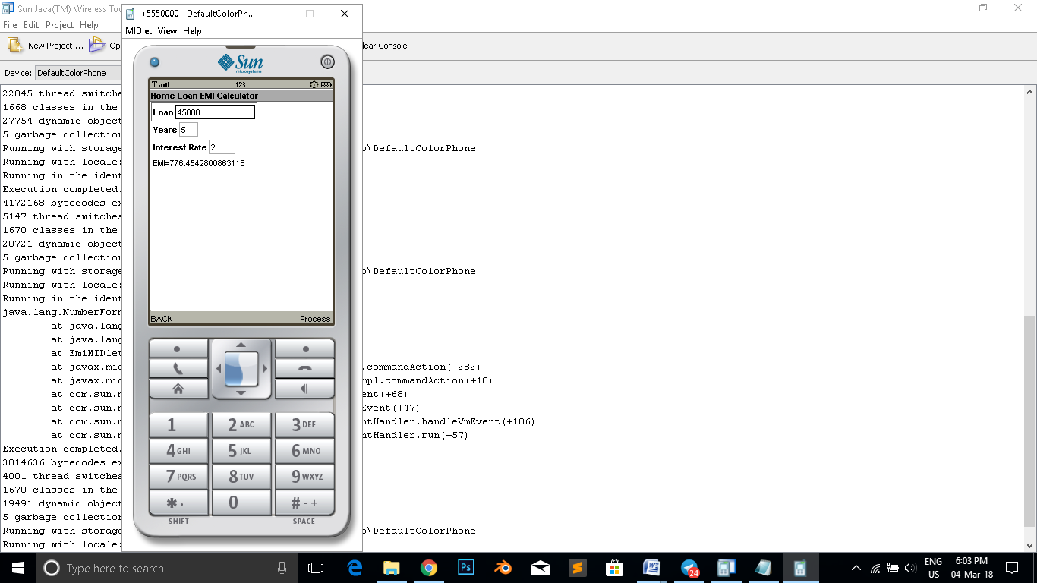

//MCC 5
Source code:
import javax.microedition.lcdui.*;
import javax.microedition.midlet.*;
import java.io.*;
public class Calculator extends MIDlet implements CommandListener{
private Form form;
private Display display;
private TextField input1, input2;
private Command add, sub, mul,div;
private StringItem item;
public Calculator(){ }
public void startApp(){
display = Display.getDisplay(this);
Form form = new Form("Calculator");
item = new StringItem("Result =", "");
input1 = new TextField("First Number:", "", 30, TextField.NUMERIC);
input2 = new TextField("Second Number", "", 30, TextField.NUMERIC);
form.append(input1);
form.append(input2);
add = new Command("Addition", Command.OK, 1);
sub = new Command("Subtraction", Command.OK, 1);
mul = new Command("Multiplication", Command.OK, 1);
div = new Command("Division", Command.OK, 1);
form.addCommand(add);
form.addCommand(sub);
form.addCommand(mul);
form.addCommand(div);
form.append(item);
form.setCommandListener(this);
display.setCurrent(form); }
public void pauseApp() { }
public void destroyApp(boolean uncondn){
notifyDestroyed(); }
private void calculate()
{int one=Integer.parseInt(input1.getString());
int two= Integer.parseInt(input2.getString());
int result=one+two;
item.setText( result + "" );}
private void calculate1(){
int one = Integer.parseInt(input1.getString());
int two = Integer.parseInt(input2.getString());
int result = one - two;
item.setText(result + ""); }
private void calculate2() {
int one = Integer.parseInt(input1.getString());
int two = Integer.parseInt(input2.getString());
int result = one * two;
item.setText(result + ""); }
private void calculate3() {
int one = Integer.parseInt(input1.getString());
int two = Integer.parseInt(input2.getString());
int result = one / two;
item.setText(result + ""); }
public void commandAction(Command c, Displayable d) {
String label = c.getLabel();
if (label.equals("Addition")) {
calculate(); }
else if (label.equals("Subtraction")) {
calculate1(); }
else if (label.equals("Multiplication"))
{ calculate2();
form.append("The Answer is:"); }
else if (label.equals("Division"))
{calculate3();
form.append("The Answer is:");}}}

Output:

